Cambridge IGCSE Business Studies • Chapter 18

Production of Goods and Services
This chapter explains how businesses turn resources into goods and services, improve productivity, manage inventory, reduce waste through lean production, choose between job, batch and flow production, and use technology such as automation, mechanisation, CAD and CAM.
Production processProductivityInventoryLean productionJob, batch and flowTechnology

Topic 1: Production, Factors of Production and Productivity
Start with the basic production process, then separate production from productivity.

1. Production
Production is the provision of goods or services to satisfy customer wants and needs.
Businesses combine the four factors of production to produce goods and services:
LandLabourCapitalEnterprise
The production process also adds value to inputs such as raw materials and components.
Inputs→Production process→Outputs
Example: Ingredients + workers + equipment → Restaurant prepares meal → Meal served to customer.
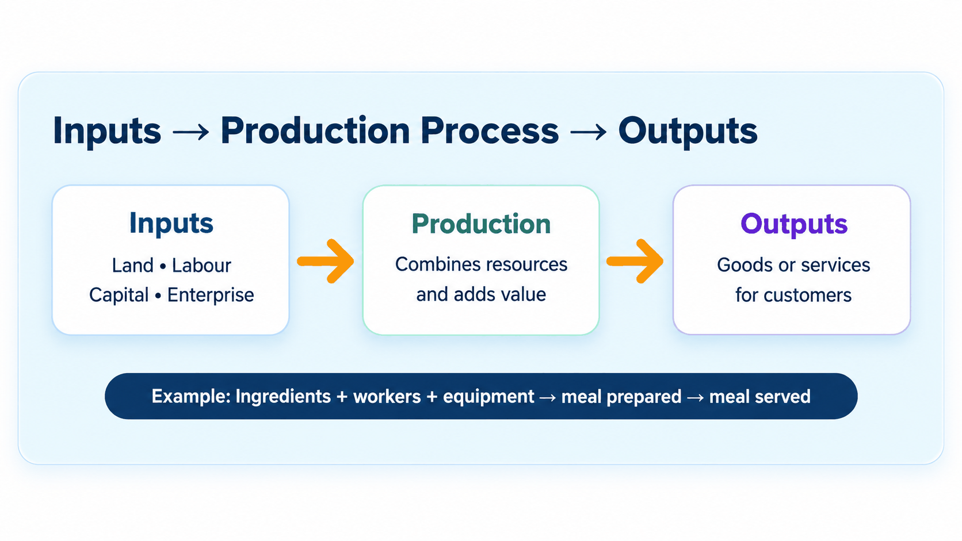

2. Labour-Intensive and Capital-Intensive Production

Labour-Intensive Production
A business uses more workers and relatively fewer machines.

Suitable where:
- labour costs are low
- personal service is important
- products require skilled handwork.

Capital-Intensive Production
A business uses more machinery, equipment or automation and relatively fewer workers.

More common where:
- labour costs are high
- large quantities are produced
- automation can increase efficiency.

3. Production and Productivity
These terms are different and should not be mixed up in the examination.

Production
The total amount of output produced during a period of time.

Productivity
Measures how efficiently resources are being used.
Labour productivity = Total output ÷ Number of workers
Example: A factory produces 12,000 units using 40 workers. Labour productivity = 300 units per worker.

4. How Productivity Can Be Increased
Important methods include:
- Employee training: Better-trained workers can work more efficiently.
- Improved motivation: Motivated employees may work harder and produce more.
- Automation and new technology: Machines can increase production speed and accuracy.
- Better quality and inventory control: Reducing defects and waste lowers the amount of resources wasted.

5. Benefits of Increased Productivity

Lower Average Costs
More output is produced from the same resources.

Greater Competitiveness
Lower costs may allow the business to charge lower prices.

Higher Profits
If costs per unit fall, profit may increase.

Possible Higher Wages
The business may be able to reward workers for improved productivity.
Useful chain: Higher productivity → Lower cost per unit → More competitive prices / higher profit.
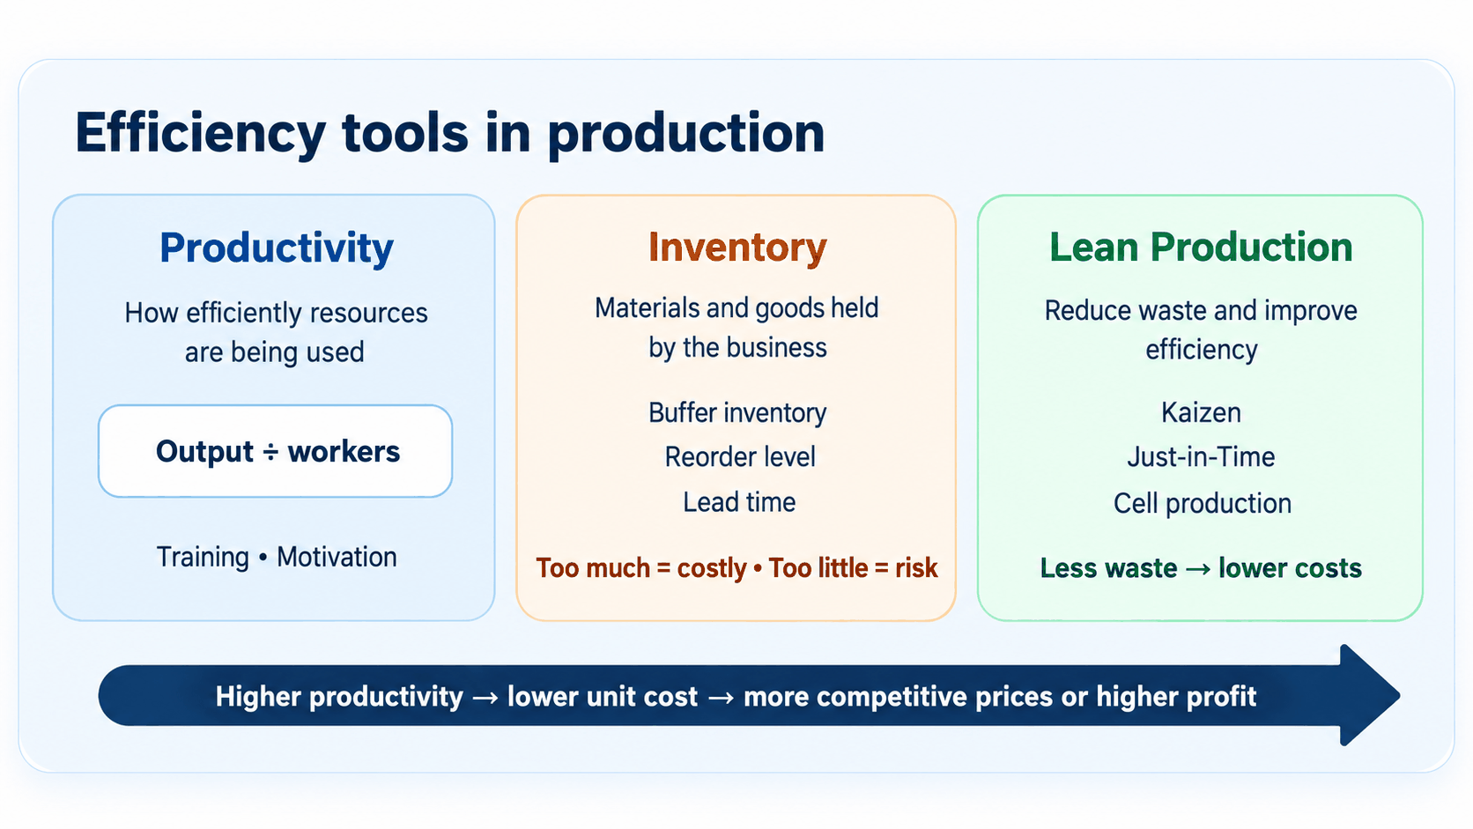

Topic 2: Inventory and Lean Production
Inventory helps businesses keep production running, but too much inventory increases costs.

6. Inventory
Inventory, also called stock, includes items held by a business.
Inventory may include:
- raw materials
- components
- partly finished goods
- finished goods.
Businesses hold inventory so that production can continue and customer demand can be met.

7. Why Businesses Hold Inventory
- Meet customer demand: Finished products need to be available when customers want them.
- Keep production running: Raw materials and components are needed to avoid delays in production.
- Deal with unexpected problems: Extra inventory can protect the business if demand suddenly increases or deliveries arrive late.

8. Important Inventory Terms

Buffer Inventory
The minimum inventory held to deal with unexpected changes in demand or delays in supply.

Reorder Level
The inventory level at which the business places a new order.

Lead Time
The time between placing an order and receiving the goods.

Maximum Inventory Level
The highest amount of inventory the business plans to hold.
Important: Holding too much inventory is costly because money is tied up in goods that are not being used or sold. Holding too little creates a risk of running out.

9. Lean Production
Lean production involves reducing waste in order to increase efficiency.
It removes activities that do not add value to the product or service. Examples of waste include:
- excess inventory
- unnecessary movement
- waiting time
- defects
- overproduction.
Students do not need to memorise every possible type of waste, but should understand the general idea.

10. Benefits of Lean Production
- Lower costs: Less inventory and waste reduce business costs.
- Faster production: Unnecessary processes are removed.
- Better use of resources: Employees, machinery and materials are used more efficiently.
Lower costs can make the business more competitive and increase profit.

11. Methods of Lean Production
Important methods include:
KaizenJust-in-Time (JIT)Cell production

12. Kaizen
Kaizen means continuous improvement through the elimination of waste.
Employees regularly suggest small improvements to the production process.

Benefits
- increases productivity
- reduces waste
- workers become involved in improving the business.
Rather than making one very large change, Kaizen focuses on many small continuous improvements.

13. Just-in-Time (JIT)
Just-in-Time inventory control involves receiving raw materials and producing goods only when they are needed.
The business therefore keeps very little inventory.

Advantages
- Lower storage costs.
- Less money tied up in inventory.
- Less risk of goods becoming damaged or outdated.

Disadvantages
- The business depends heavily on reliable suppliers.
- A late delivery could stop production.
Exam link: JIT works best when suppliers can provide materials quickly and reliably.

14. Cell Production
Cell production divides production into small groups or cells.
Each group is responsible for producing an identifiable part of the final product.
This can:
- improve teamwork
- increase employee responsibility
- improve motivation and efficiency.

Topic 3: Main Methods of Production
Businesses choose between job, batch and flow production depending on the product and demand.

15. Main Methods of Production
There are three main production methods:
Job productionBatch productionFlow production
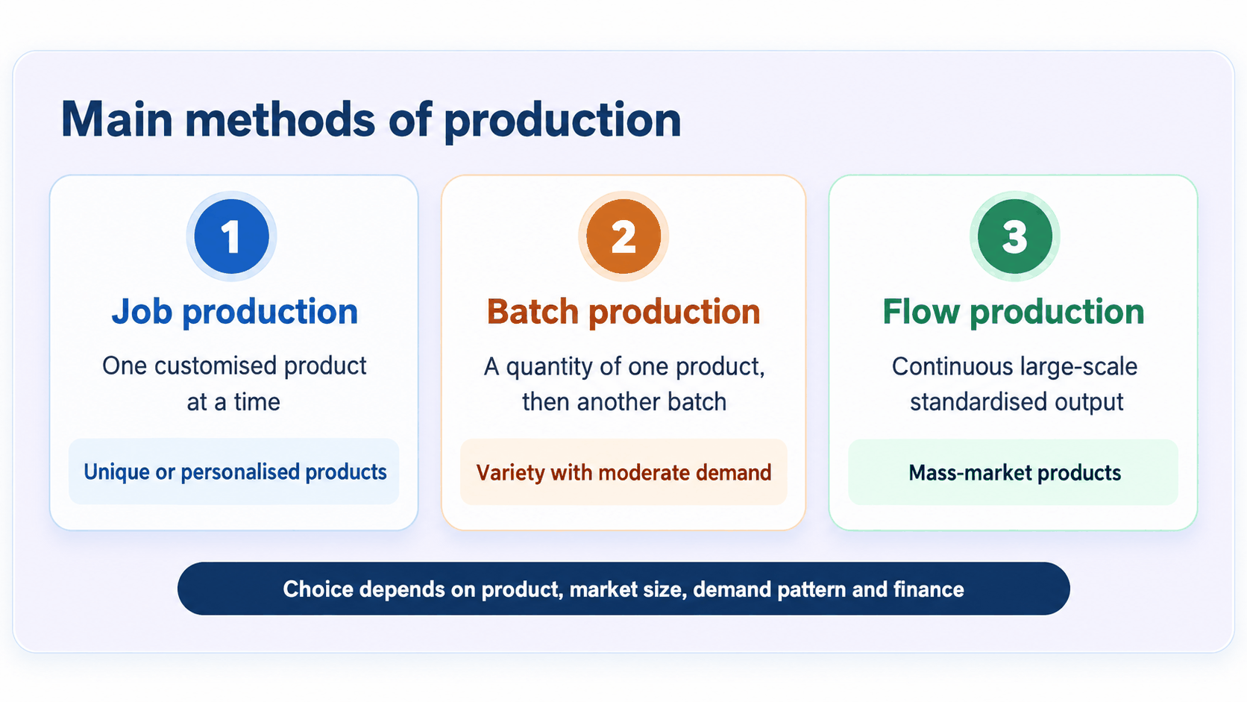

16. Job Production
Job production means producing one product at a time, usually to meet the exact requirements of a customer.

Examples
- made-to-measure suit
- specialist machinery
- ship
- customised computer program.

Advantages
- Product can meet the customer's exact requirements.
- Products can be high quality and may sell for high prices.
- Workers may have more varied and satisfying jobs.

Disadvantages
- Skilled labour can make production expensive.
- Production can take a long time.
- Cost per unit is usually high.

17. Batch Production
Batch production means producing a quantity of one product and then changing production to produce a quantity of another product.

Examples
- bakery producing different types of bread
- clothing in different sizes
- different styles of furniture.

Advantages
- Allows a variety of products to be made.
- More flexible than flow production.
- Workers may have more variety in their jobs.

Disadvantages
- Machines may need to be reset between batches, causing delays.
- Inventory may need to be stored.
- Moving partly finished goods between production stages can increase costs.

18. Flow Production
Flow production, also called mass production, involves producing large quantities of a standardised product continuously.

Examples
- cars
- televisions
- packaged foods
- soft drinks.

Advantages
- Very high output.
- Low average cost per unit.
- Automation can be used extensively.
- Products can be produced continuously.

Disadvantages
- Production-line work can be repetitive and boring.
- Setting up the production line can be very expensive.
- If one important machine breaks down, the entire production line may stop.

19. Comparing Production Methods
Method | Main Feature | Suitable For
Job | One customised product at a time | Unique or personalised products
Batch | Groups of similar products | Variety with moderate demand
Flow | Continuous production of large quantities | Standardised mass-market products

20. Choosing the Right Production Method
The choice depends mainly on:
- Nature of the product: A unique product may require job production, while a standardised product may use flow production.
- Size of the market: Small or niche market → job/batch. Large mass market → flow.
- Level and pattern of demand: Large and steady demand makes flow production more suitable.
- Size and finance of the business: Flow production often requires expensive machinery, so smaller businesses may be more likely to use job or batch production.

Topic 4: Technology and Production
Technology can increase productivity and quality, but it can also create costs and job losses.

21. Technology and Production
Technology has made many businesses more capital-intensive.
Important examples include:
AutomationMechanisationCADCAM

22. Automation
Automation occurs when production equipment is controlled by computers and carries out processes with little human involvement.
Example: Robots painting or welding cars on a production line.

23. Mechanisation
Mechanisation occurs when machines carry out production tasks but are still operated by workers.
Example: A worker operating a printing machine.
Difference: Mechanisation → machine controlled by worker. Automation → machine mainly controlled by computer.

24. CAD and CAM

CAD – Computer-Aided Design
Computer software used to design or modify products.
It allows designs to be produced and changed quickly.

CAM – Computer-Aided Manufacture
Computers control machinery used to manufacture products.
For example, computers may control robots on a car production line.

25. Advantages of New Technology
- Higher productivity: Machines can produce goods quickly and efficiently.
- Better quality: Automated equipment may be more accurate and consistent.
- Lower average costs: Higher efficiency may reduce production costs per unit.
- Improved decision-making: Computer systems can provide managers with more accurate and up-to-date information.

26. Disadvantages of New Technology
- High cost: Machinery, computers and software can require large investment.
- Job losses: Machines may replace some workers.
- Training needed: Employees may need new skills to operate and maintain technology.
- Technology can become outdated: Businesses may have to replace expensive equipment to remain competitive.

Topic 5: Key Definitions and Exam Focus
Use these terms accurately when answering case-study questions.

Key Definitions
Term | Meaning
Production | Provision of goods or services to satisfy customer needs and wants
Productivity | Output compared with the inputs used to produce it
Labour-intensive | Production using relatively more workers than machinery
Capital-intensive | Production using relatively more machinery than workers
Inventory | Raw materials, components, partly finished or finished goods held by a business
Buffer inventory | Inventory held to deal with unexpected demand or supply delays
Lean production | Techniques used to reduce waste and increase efficiency
Kaizen | Continuous improvement through eliminating waste
JIT | Inventory system where materials and goods arrive or are produced only when required
Job production | One product produced at a time
Batch production | Quantity of one product produced before changing to another
Flow production | Continuous production of large quantities of standardised products
Automation | Computer-controlled production equipment
Mechanisation | Machines used in production but operated by workers
CAD | Computer-Aided Design
CAM | Computer-Aided Manufacture

What Students Must Know for the Examination
Students should be able to:
- distinguish between production and productivity
- calculate labour productivity
- explain important ways of increasing productivity
- explain why businesses hold inventory
- understand buffer inventory, reorder level and lead time
- explain lean production
- explain Kaizen and JIT
- distinguish between job, batch and flow production
- explain important advantages and disadvantages of each production method
- recommend the most suitable production method for a business
- distinguish between labour-intensive and capital-intensive production
- explain how automation, mechanisation, CAD and CAM affect production
- explain important benefits and drawbacks of introducing new technology.

